TICKET BOOKING PLATFORM
@CREATIVITY THINK (9483175986/7019689991)

ABSTRACT:
Ticket Booking Platform is a web application designed to simplify event ticket reservations for movie theaters, concerts, and sports events. Users can browse events, select seats, book and pay online, download e-ticket PDFs, and view booking history. Administrators manage event listings and seat plans, monitor sales and disputes, and push offers or updates through dashboards. Built with Django and Django Rest Framework for backend operations and React with pdfkit and Chart.js for frontend dashboards, the system ensures a seamless booking experience, accurate seat management, and comprehensive analytics for event organizers..

INTRODUCTION OF THE PROJECT:
Managing ticket bookings manually is time-consuming and prone to errors, especially for popular events. Ticket Booking Platform offers a centralized web solution where users can browse events, select seats, make payments, download e-tickets, and view their booking history. Administrators manage events, optimize seat allocation, track sales and disputes, and provide updates or promotions via dashboards. Utilizing Django for backend services and React with pdfkit and Chart.js for interactive dashboards, the platform ensures efficiency, transparency, and enhanced user satisfaction in event ticket management..

PROJECT OBJECTIVES:

• Provide a centralized platform for event ticket booking
• Allow users to browse events and select seats efficiently
• Enable secure online booking and payment
• Generate e-ticket PDFs for users
• Maintain booking history and user dashboards
• Allow administrators to manage events and seat plans
• Track sales, resolve disputes, and analyze data through dashboards

PROBLEM OF THE STATEMENT:
Event organizers face challenges in managing ticket sales manually, including seat allocation errors, payment tracking issues, and difficulty analyzing sales data. Ticket Booking Platform addresses these challenges by providing a centralized web system for booking tickets, managing seats, generating e-tickets, and tracking booking history. Administrators gain oversight of events, sales, disputes, and promotions through dashboards and analytics, ensuring efficient, transparent, and real-time ticket management for both users and event organizers..

MOTIVATION OF THE PROJECT:
• Simplify ticket booking and payment processes for users
• Ensure accurate seat allocation and avoid double bookings
• Provide downloadable e-tickets for convenience
• Allow administrators to monitor sales, disputes, and promotions
• Generate dashboards and analytics for data-driven decisions

BLOCK DAIGRAM OF PROJECT:

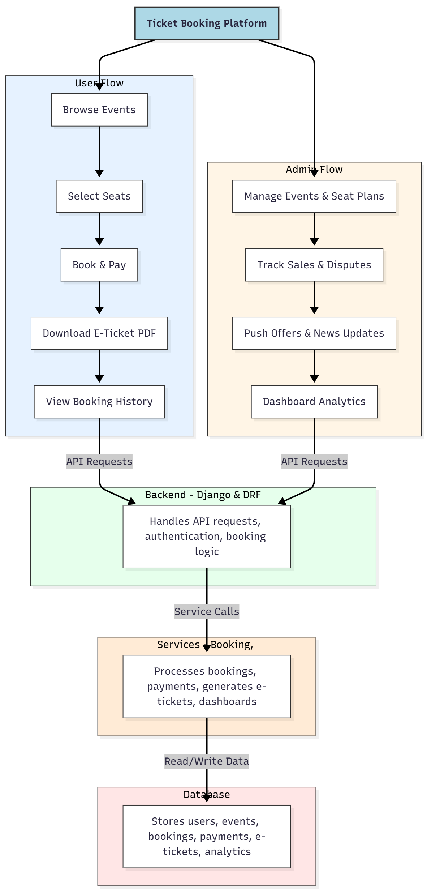

WORKING OF THE PROJECT:
Users browse available events, select their preferred seats, complete booking and payment online, download e-ticket PDFs, and track booking history on dashboards. The backend handles authentication, booking logic, and API requests. Services manage booking processing, payment handling, e-ticket generation, and analytics dashboards. Administrators manage event listings, seat plans, monitor sales and disputes, push promotions, and generate comprehensive analytics dashboards. The system ensures efficient, accurate, and transparent ticket booking and event management..

SOFTWARE REQUIREMENT:
- Backend:
  - Python 3.x
  - Django
  - Django REST Framework
  - SQLite/PostgreSQL
- Frontend:
  - Node.js and npm
  - React.js
  - Axios
- Development Tools:
  - Visual Studio Code
  - Postman (for testing APIs)
  - Git/GitHub (for version control)
- Server/Deployment (Optional):
  - Gunicorn, Nginx, or Heroku/AWS for hosting

ADVANTAGES OF THE PROJECT:

• Streamlines ticket booking and seat selection
• Generates downloadable e-ticket PDFs
• Provides real-time booking history and dashboards
• Administrators can manage events and seats efficiently
• Tracks sales, resolves disputes, and pushes offers
• Dashboard analytics for informed decision-making
• Reduces manual errors and double bookings
• Enhances user experience and operational efficiency

APPLICATIONS OF THE PROJECT:
• Movie theaters ticket bookings
• Concert and sports event reservations
• Theater or performance ticketing
• Online booking platforms for events
• Real-time analytics for event organizers
• Promotions and offers management
• Customer dashboards for bookings and history
• Payment tracking and reporting

REFERENCES:

- Django REST Framework Documentation — Django Software Foundation. Django Documentation. Available: https://docs.djangoproject.com/
- Django REST Framework. DRF Documentation. Available: https://www.django-rest-framework.org/
- React. React Official Documentation. Available: https://reactjs.org/docs/getting-started.html
- Redux. Redux Documentation. Available: https://redux.js.org/introduction/getting-started
- PostgreSQL Global Development Group. PostgreSQL Documentation. Available: https://www.postgresql.org/docs/
- MySQL. MySQL Reference Manual. Available: https://dev.mysql.com/doc/
- Git. Git Documentation. Available: https://git-scm.com/doc
- Node.js. Node.js Documentation. Available: https://nodejs.org/en/docs/
- Axios. Axios Documentation. Available: https://axios-http.com/docs/intro
- Socket.io Documentation – https://socket.io/docs/

